Project number: 5

Project for Advanced Software Engineering Course

Gaith-غَيث

Supervised by: Prof. Amjad Hudaib

|  |  |  |  |  |
| --- | --- | --- | --- | --- |
|  | **Student Id** | **Student Name** | **Section** | **No.** |
| 1 | 0203422 | Yara Feras Al-Rbehat | 1 | 17 |
| 2 | 0204879 | Lara Salmeh Al-Qaise | 1 | 22 |
| 3 | 2200416 | Heba Ibraheem Al-Rimawi | 1 | 36 |
| 4 | 2200593 | Monia Waleed Dahnoon | 1 | 37 |

Summer Semester 2022/2023

Table of Contents

Introduction 6

1.1 Overview (Idea) 6

1.2 Main Objectives 6

1.3 Main Motivations 7

1.4 Constraints 7

1.5 Similar Projects 7

1.6 Project Organization 7

Project Management 8

2.1 Feasibility study 8

2.1.1 Technical Feasibility 8

2.1.2 Operational Feasibility 9

2.1.3 Legal Feasibility 10

2.2 The Needed Hardware and Software 10

2.3 The Schedule and The Estimated Time: 10

2.3.1 Schedule 10

2.3.2 Pert Diagram 13

Project Specifications 15

3.1 Stakeholder 15

3.2 Data Gathering Techniques: 16

3.2.1 Interview: 16

3.2.2 Survey: 21

3.3 Functional Requirements 24

3.4 Non-Functional Requirements 29

3.5 Domain Requirements 30

3.6 Requirements Analysis and the Architecture Design 31

Project Design 32

4.1 Class Diagram 32

32

4.2 Use case Diagram 36

4.2.1 USE-CASE Description 37

4.3 Sequence Diagrams 40

5.1 Project Implementation 46

5.1.1 The Programming Language. 46

Segment of the most important part of implementation 46

6.1 Project Testing 52

6.1.1Test cases 52

6.1.2 Test methodologies 53

7.1 User Manual 56

References 63

Appendix 63

Table of Table

Table 1: Needed Hardware and Software 9

Table 2: Project schedule 10

Table 3: Stakeholders 14

Table 4: Functional Requirements 23

Table 5: Non-Functional Requirements 28

Table 6: Domain Requirements 29

Table 7: Increment 31

Table 8: Use Cases Description: 37

Table 9: Test Cases 52

Table 10: Heuristic evaluation 53

Table 11: Summary of Violations by Heuristics 54

Table 12: Severity rating and their Description 54

Table 13: Summary of Violations by Severity Rating for Participant (1) 55

Table 14: Summary of Violations by Severity Rating for Participant (2) 55

Table 15: Summary of Violations by Severity Rating for Participant (3) 55

Table of Figure

[Figure 1: Pert Diagram 13](https://fisjo-my.sharepoint.com/personal/yar0203422_ju_edu_jo/Documents/Adv-Software(p1).docx#_Toc143632513)

[Figure 2: Questionnaire 20](https://fisjo-my.sharepoint.com/personal/yar0203422_ju_edu_jo/Documents/Adv-Software(p1).docx#_Toc143632514)

[Figure 3: Architecture Design 30](https://fisjo-my.sharepoint.com/personal/yar0203422_ju_edu_jo/Documents/Adv-Software(p1).docx#_Toc143632515)

Figure 4: Class Design 31

[Figure 5: Use case Diagram 35](https://fisjo-my.sharepoint.com/personal/yar0203422_ju_edu_jo/Documents/Adv-Software(p1).docx#_Toc143632517)

[Figure 6:Log in. 39](https://fisjo-my.sharepoint.com/personal/yar0203422_ju_edu_jo/Documents/Adv-Software(p1).docx#_Toc143632518)

[Figure 7:Sign up 40](https://fisjo-my.sharepoint.com/personal/yar0203422_ju_edu_jo/Documents/Adv-Software(p1).docx#_Toc143632519)

[Figure 8: Denote blood 40](https://fisjo-my.sharepoint.com/personal/yar0203422_ju_edu_jo/Documents/Adv-Software(p1).docx#_Toc143632520)

Figure 9: Bood donation fields 41

[Figure 10: The food parcels. 41](https://fisjo-my.sharepoint.com/personal/yar0203422_ju_edu_jo/Documents/Adv-Software(p1).docx#_Toc143632522)

[Figure 11: Orphans 42](https://fisjo-my.sharepoint.com/personal/yar0203422_ju_edu_jo/Documents/Adv-Software(p1).docx#_Toc143632523)

[Figure 12: Orphans fields 43](https://fisjo-my.sharepoint.com/personal/yar0203422_ju_edu_jo/Documents/Adv-Software(p1).docx#_Toc143632524)

[Figure 13: Mosque 43](https://fisjo-my.sharepoint.com/personal/yar0203422_ju_edu_jo/Documents/Adv-Software(p1).docx#_Toc143632525)

Figure 14: Logout 44

[Figure 15: Registration 45](https://fisjo-my.sharepoint.com/personal/yar0203422_ju_edu_jo/Documents/Adv-Software(p1).docx#_Toc143632527)

[Figure 16: Home Page 48](https://fisjo-my.sharepoint.com/personal/yar0203422_ju_edu_jo/Documents/Adv-Software(p1).docx#_Toc143632528)

Chapter One

# Introduction

## 1.1 Overview (Idea)

A website that collects everything a person in Jordan is looking for to donate in various forms.

## 1.2 Main Objectives

* Opportunities to donate blood to people in need and cover the need for blood.
* The possibility of contributing to meeting the orphan’s basic needs such as food.
* Providing the opportunity to contribute to the restoration and improvement of mosques.
* The Food Parcels Donation Program aims to provide individuals and families in need with a reliable and consistent source of nutritious food.
* Payment and donation processes are easy on the website that we will develop, and it will be through electronic payment platforms available in Jordan, such as efawateercom and CliQ.

## 1.3 Main Motivations

- To meet the need for facilitating various forms of donation, providing quick access through technological support, and enhancing reliability in cooperation with various government agencies.

- And believing that we can make a positive impact in society and make a real difference in people’s lives.

## 1.4 Constraints

- The donation entities in this website are attached to official authorities

- To provide a place where all kinds of non-cash donations can be given and directed to its appropriate entity.

## 1.5 Similar Projects

* إحسان: ehsan.sa
* شفاء:shefa.sa/condition/17799/detail

## 1.6 Project Organization

* Minister of Health-Blood Bank manager
* Ministry of Social Development
* Ministry of Endowments (Al-Awqaf)

Chapter Two

# Project Management

## 2.1 Feasibility study

### 2.1.1 Technical Feasibility

* Website Development: Developing a website to facilitate donations would require expertise in web development technologies such as HTML, CSS and JavaScript. Therefore, we need a front-end developer. A cloud-based web server is needed to host the website. The website should have a user-friendly interface that allows individuals to search for donation items, browse donation categories, and submit their donations. However, we will provide a training program to ensure that users are familiar with the website's functionalities.
* Database Management: The database should efficiently handle the storage and retrieval of donation details, donor information, and item categorization. So, we need a database administrator.
* User registration and authentication are crucial features for the website. Users should be able to register and create accounts to manage their donations. To ensure security, the website needs to implement robust authentication mechanisms, to safeguard user data.
* Security and Privacy: Implementing security measures, including data encryption, secure connections (HTTPS), and regular backups, Compliance with data protection regulations, such as GDPR or local privacy laws.
* Scalability and Performance: Employing scalable infrastructure and optimizing website performance.

### 2.1.2 Operational Feasibility

Some of the main problems that we aim to avoid them:

-lack of trust is a problem related to donations, as some people may be hesitant to donate due to concerns over whether their donation will be used for its intended purpose.

- Limited resources: While some individuals or organizations may be willing to donate, they may not have the financial resources to do.

-Inefficiency: In some cases, the process of donating can be inefficient, with a large portion of funds going towards administrative costs rather than the intended cause

### 2.1.3 Legal Feasibility

proposed project confirms the legal and ethical requirement, and the proposed system is completely fine with the legal and ethical terms. However, there’s some point that needs to be clarified:

•The development team Own the rights of The Source Code, in addition to that any new feature will be considered as a new version that has its cost.

## 2.2 The Needed Hardware and Software

Table 2.1 presents the needed Hardware and Software to develop the project and their estimated cost

Table 1: Needed Hardware and Software

|  |  |  |  |  |  |
| --- | --- | --- | --- | --- | --- |
|  | Description | Quantity | Unit Price  (JD) | Total Price | Note |
| HD1 | Laptops | 4 | 650 JD | 2600 JD |  |
| HD2 | Printers | 2 | 115 JD | 230 JD |  |
| SW1 | cloud-based web server | 1 | 102 JD per year | Infant |  |
| SW2 | PHP myAdmin | - | Free |  |  |
| SW5 | Figma | 1 | Free |  |  |
| SW6 | VS code | 4 | Free |  |  |
| Total | **Fixed cost: 2830 JD + 102 per year** | | | | |

## 2.3 The Schedule and The Estimated Time:

### 2.3.1 Schedule

The Project Schedule is presented in Table 1

Table 2: Project schedule

|  |  |  |  |  |  |
| --- | --- | --- | --- | --- | --- |
| **Task ID** | **Description** | **Duration**  **Time (WD)** | **Dependency** | **Responsible**  **Partner/s, Staff** | **Resources** |
| T1 | Data gathering for Gather information and concepts about the project. | 4 Days  (13/7/2023to 16/7/2023) | None |  | 1) good writing skills. 2)zoom platform |
| T2 | Prepare a project management plan for A descriptive structure to the project that must be done within a certain timeframe by showing the software process model and how the project will be executed and monitored | 13 Days  (17/7/2023to 31/7/2023) | T1 |  | good communication skills between team members |
| T3 | study the feasibility of the project for A study that analyzes the project to figure out if it is feasible and applicable to the aspects of the project. The study will also show if the investment in the project will be successful or not | 3 Days  (1/8/2023 to 3/8/2023) | T1&T2 (M1) |  | 1)spreadsheets like: Microsoft excel. 2)Being able to deal with financial issues |
| T4 | Writing Functional and non-functional req for A roadmap and a description for the software that helps to fully understand it | 3 Days  (4/8/2023 to 6/8/2023) | T1& T3 |  | Business analyst |
| T5 | write use case diagrams and description for each for must do a diagram that represents the interactions between actors and use cases in a system. | 3 Days  (7/8/2023 to 9/8/2023 ) | T3,T4 |  | lucid.app |
| T6 | prepare UML diagrams for  a Unified Modeling Language that represents different aspects of a system. | 3 Days  (10/8/2023to 12/8/2023) | T5 (M2) |  | lucid.app app.creately |
| T7 | design the physical database for the logical design of a database | 3 Days  (13/8/2023to 15/8/2023) | T5,T6 |  | Microsoft Access |
| T8 | design architecture of the system for a clear and flexible structure for the system | 4 Days  (16/8/2023 to 19/8/2023) | T5,T6 |  | photoshop |
| T9 | design graphical user interface for A good GUI should be user-friendly and should provide clear and easy access to the functionality of the system | 4 Days  (20/8/2023to 23/8/2023) | T6,T8 |  | Figma (cloud-based design tool) |
| T10 | implement the graphical user interface for writing code, then adding functionality | 3 Days  (24/8/2023to 26/8/2023) | T7,T9 |  | 1)HTML, CSS, JavaScript programmer  2)Visual studio |
| T11 | Test the system for to ensure the system meets requirements and functions correctly. | 3 Days  (27/8/2023to 29/8/2023) | T9,T10 (M3) |  | - |
| T12 | prepare the user manual for  A guide that helps users to know how to use the website | 2 Days  (30/8/2023to 31/8/2023) | T5,T9,T10,T11 |  | Figma |

### 2.3.2 Pert Diagram

Figure : Pert Diagram

Estimated Time (WD) = 48 days (WDs)

Chapter Three

# Project Specifications

## 3.1 Stakeholder

Table : Stakeholders

|  |  |  |
| --- | --- | --- |
| ST ID | Stakeholder | Note |
| ST1 | Users: Individuals who are potential blood donors, clothing contributors, donors to the orphan's needs, contributors to mosque restoration, and supporters of environmental initiatives |  |
| ST2 | Ministry of Social Development: Involved in coordinating and supporting initiatives related to meeting the needs of orphans, and collect data on poor families for food parcel |  |
| ST3 | Civil service consumer corporation :Collaborate with Civil service consumer corporation for sourcing the food items |  |
| ST4 | Ministry of Endowments (Alwqaf) : Involved in mosque restoration and improvement initiatives. |  |
| ST5 | Minister of Health-Blood Bank manager :Responsible for overseeing and coordinating blood donation initiatives and managing the Blood Bank. |  |
| ST6 | Ministry of Endowments (Alwqaf) : Involved in mosque restoration and improvement initiatives. |  |
| ST7 | Minister of Health-Blood Bank manager: Responsible for overseeing and coordinating blood donation initiatives and managing the Blood Bank. |  |

## 3.2 Data Gathering Techniques:

### 3.2.1 Interview:

Interview: we gathered information and requirements from project lead to understand their needs and expectations for a software project. It involves asking questions and discussing various aspects of the project to ensure a clear understanding of the scope, requirements, and desired outcomes. The information collected during interviews serves as the foundation for designing and developing an effective.

o The Interview:

Lara: Can you provide an overview of the registration process and the information you collect from users?

Mr. Firas: Certainly. During the registration process, users are required to fill out a form with their personal information. This includes their full name, phone number, age, and residential address. Additionally, there are two checkboxes that allow users to select their notification preferences. If a user expresses interest in blood donation, further options are displayed, such as blood type, weight, health status, and gender. If a user selects orphan sponsorship, they will receive notifications when an orphan without a sponsor requires sponsorship.

Lara: That sounds like a comprehensive registration process. Now, let's discuss the login functionality. How do users access their accounts?

Mr. Firas: To log in, users enter their phone number. Once entered, a verification code is sent to their phone to ensure secure access to their account.

Lara: Great. Now, let's talk about the language selection feature. How does your system allow users to choose their preferred language?

Lara: Our system includes a language selection feature in the user profile settings. Users can choose between Arabic and English as their preferred language, and the system will adapt accordingly to display the content in their chosen language.

Lara: Excellent. Let's move on to the blood donation aspect of your project. How does your system facilitate blood donation scheduling and communication with donors?

Mr. Firas: Our system allows users to schedule blood donation appointments conveniently. It provides a user-friendly interface where donors can select suitable dates and times for their appointments. Additionally, we have a notification system in place to remind donors about upcoming blood donation drives or urgent blood needs, ensuring effective communication and participation.

Lara: That's impressive. Now, could you tell us more about the donor tracking aspect? How does your system maintain records and history for tracking and follow-up purposes?

Mr. Firas: Our system maintains a comprehensive record of donors and their donation history. This includes details such as the dates and types of donations made by each donor. By tracking this information, we can ensure a consistent supply of blood and provide follow-up support or gratitude to donors as needed.

Lara: Moving on to orphan support, how does your system facilitate monetary donations and ensure transparency?

Mr. Firas: Our system provides a dedicated section for collecting monetary donations to support orphans' basic needs. Users can contribute by paying a monthly sponsorship amount of 25 JD. To ensure transparency and accountability, we provide regular reports on the utilization of funds, demonstrating how the donations are making a difference in the lives of the sponsored orphans.

Lara: That's commendable. How does your system indicate the sponsorship status of an orphan and handle sponsorship renewal?

Mr. Firas: The system clearly indicates whether an orphan is currently sponsored or not. This information is displayed alongside the orphan's profile or in a designated section. Additionally, the system tracks the duration of each sponsorship period, showing the start date and the number of months it has been ongoing. If the sponsorship period expires, the system sends a notification or reminder to the user, encouraging them to renew their sponsorship if they wish to continue their support.

Lara: Let's move on to the Food Parcels program. How does your system handle partnerships, parcel composition, and donation options?

Mr. Firas: Our system collaborates with the Civil Service Consumer Corporation for sourcing the food items needed for the parcels, optimizing costs, and maximizing distribution. We also partner with the Ministry of Social Development to collect data on poor families. The system offers three flexible donation options: food parcels for 1-2 persons priced at 18 JD, for 3-5 persons priced at 35 JD, and for 6-7 persons priced at 50 JD. Users can select the desired number of food parcels they wish to donate.

Lara: That's impactful. Could you elaborate on the volunteer aspect? How do users indicate their interest and choose the most convenient time for them?

Mr. Firas: Users who wish to volunteer can indicate their interest on the website. They can choose between preparing food parcels or providing delivery services to families' houses. Once they select their preferred option, the system displays available slots and appointments. Users can then choose the most convenient time for their volunteering activities.

Lara: Let's talk about the restoration and improvement of mosques. How does your system support these projects and facilitate financial donations?

Mr. Firas: We collaborate with the Ministry of Endowments (Al-Awqaf) to support restoration and improvement projects in need of funding. Our system provides a platform where users can make financial donations specifically for mosque restoration and improvement. This ensures that individuals can contribute directly to these projects and help preserve and enhance these important community spaces.

Lara: Lastly, let's discuss electronic payment integration. How does your system incorporate electronic payment platforms for seamless transactions?

Mr. Firas: We have integrated electronic payment platforms such as efawateercom and Click to Donate into our website. This allows users to make secure and convenient online transactions when donating or making payments for various aspects of our project. By leveraging these platforms, we aim to provide users with a smooth and hassle-free payment experience.

Lara: Thank you, Mr. Firas, for providing insights into your project's functionalities. It's evident that your system is designed to address multiple aspects of support and convenience for users. We appreciate your time and wish you continued success with your initiative.

Mr. Firas: Thank you for having me. It's been a pleasure discussing our project with you. We hope that our efforts can make a positive impact on the lives of those in need.

### 3.2.2 Survey:

Questionnaire: is a research instrument that consists of a set of questions or other types of prompts that aims to collect information from a respondent. 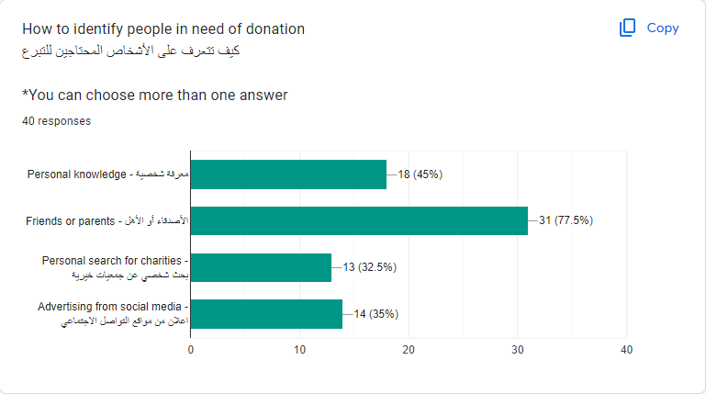

Figure : Questionnaire

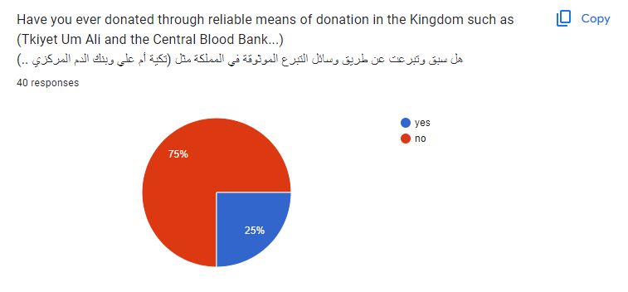

صورة تحتوي على نص, لقطة شاشة, الخط, تخطيط

تم إنشاء الوصف تلقائياً

صورة تحتوي على نص, لقطة شاشة, الخط, رقم

تم إنشاء الوصف تلقائياً

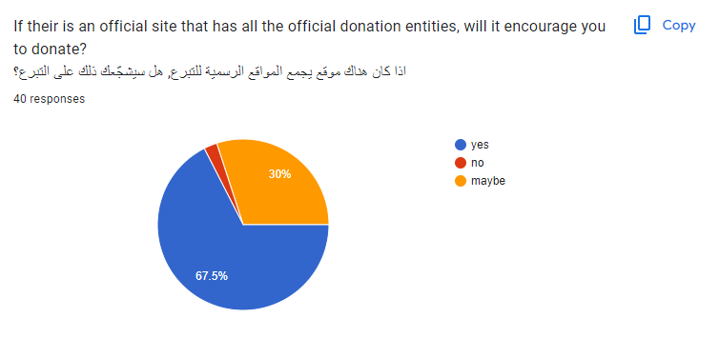

صورة تحتوي على نص, لقطة شاشة, الخط, رسم بياني

تم إنشاء الوصف تلقائياً

## 3.3 Functional Requirements

The functional requirements are shown in Table 3.3

Table : Functional Requirements

|  |  |  |  |  |
| --- | --- | --- | --- | --- |
| FR-ID | Description | ST | Priority | Note |
| FR1 | The user can click sing-up the button | ST1 | 5 |  |
| FR2 | The system displays a registration form with fields for Name, Phone Number, Age, and Address. | ST1  ST7 | 5 |  |
| FR3 | The user enters the required information. | ST1 | 5 |  |
| FR4 | The user selects one or both checkboxes for Notification Purposes (Blood Donation and Orphan Sponsorship). | ST1  ST2  ST5 | 4 |  |
| FR5 | If the user selects the Blood Donation checkbox, the system displays additional fields for Blood Type, Weight, Health Status, and Gender. | ST1  ST5 | 4 |  |
| FR6 | The user submits the registration form. | ST1  ST7 | 4 |  |
| FR7 | The system validates the entered information, ensuring a unique phone number If the information is valid, the system creates a new user account and sends a verification code. | ST1  ST7 | 4 |  |
| FR8 | The user receives the verification code and follows the instructions to verify the account. | ST1  ST7 | 4 |  |
| FR9 | The user visits the login page. | ST1 | 4 |  |
| FR10 | The system provides a field for the user to enter their phone number. | ST1  ST7 | 4 |  |
| FR11 | The user enters their phone number. | ST1 | 4 |  |
| FR12 | The system sends a verification code to the user's phone number. | ST7 | 4 |  |
| FR13 | The user enters the verification code. | ST1 | 4 |  |
| FR14 | The system verifies the code and logs the user into the home page. | ST7 | 4 |  |
| FR15 | user navigates to the right most of the page,  The system presents a language selection option. | ST1  ST7 | 1 |  |
| FR16 | The user chooses their preferred language (Arabic or English)  And The system displays the user interface and content in the selected language. | ST1  ST7 | 1 |  |
| FR17 | The user can go back to the home page by clicking the back button. | ST1 | 1 |  |
| FR18 | The user clicks the blood donation program in the home page | ST1 | 4 |  |
| FR19 | The system displays available time slots and donation centers. | ST5  ST7 | 3 |  |
| FR20 | The user selects a suitable time slot and donation center. | ST1 | 3 |  |
| FR21 | The system confirms the appointment and sends a confirmation notification to the user. | ST7 | 3 |  |
| FR22 | The system sends reminders to the user about the upcoming appointment. | ST7 | 3 |  |
| FR23 | If there is an urgent blood need or a recipient requiring blood matching the user's blood type, the system sends a notification to the user. | ST5  ST7 | 3 |  |
| FR24 | The user can track their blood donation history through the system. | ST1  ST7 | 3 |  |
| FR25 | The user clicks the orphan program in the home page | ST1 | 4 |  |
| FR26 | The system provides options for making monetary donations to support orphans' basic needs. | ST1  ST2 | 3 |  |
| FR27 | The user selects the option to pay a monthly amount of 25 JD for orphan sponsorship. | ST1  ST2 | 3 |  |
| FR28 | Users can select their preferred electronic payment method during the donation process. | ST1  ST6 | 3 |  |
| FR29 | The system records the donation and updates the user's sponsorship status. | ST2  ST7 | 3 |  |
| FR30 | The system generates regular reports on fund utilization and provides transparency to donors. | ST7 | 3 |  |
| FR31 | If the user's sponsorship period expires, the system sends a notification or reminder to renew the sponsorship. | ST7 | 3 |  |
| FR32 | The user clicks the Food parcel program in the home page | ST1 | 4 |  |
| FR33 | The system offers a section that enables users to donate to the food parcels program. | ST7 | 3 |  |
| FR34 | Users are presented with three flexible donation options a. Food parcel for 1-2 persons priced at 18 JD.  b. Food parcel for 3-5 people priced at 35 JD.  c. Food parcel for 6-7 people priced at 50 JD. | ST2  ST3  ST7 | 3 |  |
| FR35 | Users can select the desired number of food parcels they wish to donate. | ST1  ST7 | 3 |  |
| FR36 | On the same page, the system includes an additional field for users who wish to volunteer. | ST7 | 2 |  |
| FR37 | Users can choose from two options:   1. Volunteer to prepare food parcels. 2. Volunteer to provide delivery services to families' houses. | ST1  ST7 | 2 |  |
| FR38 | After selecting the desired volunteer option, the system displays available slots and appointments | ST7 | 2 |  |
| FR39 | Users can select the most convenient time slot for their volunteering activity | ST1 | 2 |  |
| FR40 | The user clicks the improvement mosque program in the home page | ST1 | 4 |  |
| FR41 | The system provides a platform for accepting financial donations for mosque restoration and improvement projects. | ST4  ST7 | 3 |  |
| FR42 | Users can donate funds through the system. | ST1  ST6 | 3 |  |
| FR43 | User can go back to the home page by clicking a home button | ST1  ST7 | 3 |  |
| FR44 | User can log out | ST1  ST7 | 2 |  |

For priority; 5 means highest and 1 means lowest Priority.

## 3.4 Non-Functional Requirements

The non-functional requirements are shown in Table 3.4

Table : Non-Functional Requirements

|  |  |  |  |
| --- | --- | --- | --- |
| ID | Requirement | Description | Priority |
| NFR1 | Speed | The website should be as fast as possible to achieve the purpose.  the website won’t take more than 5 seconds to load the pages | 4 |
| NFR2 | Ease of use | The time frame should include all human and system processes. In addition, it should be easy for the user to learn how to use the website.  It will take the users 30 minutes training to use the website, a 10-minute quiz with a score out of 10 about the icons, buttons will get an average of 8.5 | 5 |
| NFR3 | Reliability | extent which it works as and when needed | 5 |
| NFR4 | Security | All data entered by user or consultant such as login information, phone number, residential address must be secured and well stored in the database. | 4 |

Priority: 1 for lowest priority, 5 for Highest Priority

## 3.5 Domain Requirements

Table : Domain Requirements

|  |  |
| --- | --- |
| DR-ID | Description |
| DR1 | As the system is a web application, internet connectivity is a must. The system must be connected at all times to the internet. The users must be connected to the internet when connecting and viewing the site as well. |
| DR2 | The users must be able to use a browser on their devices. The browser is the application that allows them to connect to the website. |

|  |  |  |
| --- | --- | --- |
| Increments | Priority | FR |
| 1 | 1 | FR15  FR16  FR17 |
| 2 | 2 | FR36  FR37  FR38  FR39  FR44 |
| 3 | 3 | FR19  FR20  FR21  FR22  FR23  FR24  FR26  FR27  FR28  FR29  FR30  FR31  FR33  FR34  FR35  FR41  FR42  FR43 |
| 4 | 4 | FR4  FR5  FR6  FR7  FR8  FR9  FR10  FR11  FR12  FR13  FR18  FR25 |
| 5 | 5 | FR1  FR2  FR3 |

Table : Increment

## 3.6 Requirements Analysis and the Architecture Design

GR1 (Regression): FR1+FR2, FR3, FR4+FR5, FR9, FR10+FR11, FR12+FR13, FR14, FR45

GR2 (Home page): FR15, FR16, FR17, FR18, FR25, FR32, FR40

GR3 (Blood Donation): FR19, FR20, FR21, FR22, FR23, FR24

GR4 (The orphan program): FR26, FR27, FR28, FR29, FR30, FR31

GR4 (Food parcel): FR33+FR34, FR35, FR36+FR37, FR38, FR39

GR5 (Improvement Mosque program): FR41, FR42

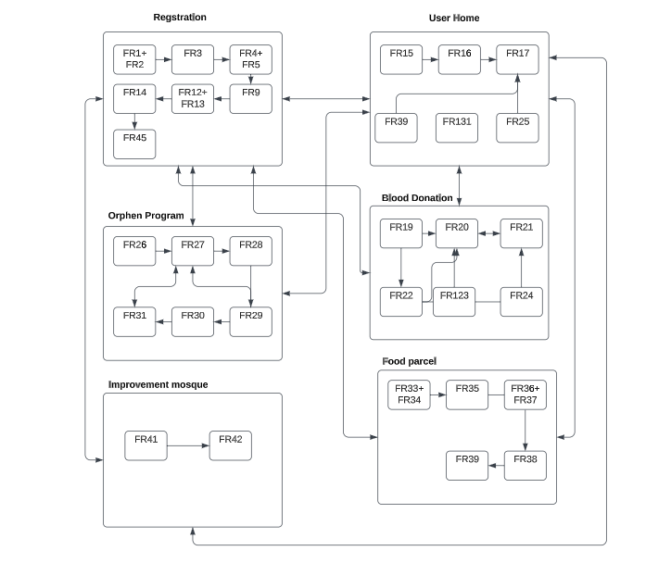

Figure : Architecture Design

Figure 3: Architecture Design

Chapter Four

# Project Design

## 4.1 Class Diagram

**

Figure : Class Design

* Identify Entities:
* User.
* Payment Details.
* Electronic Payment Integration.
* Mosque Donation Platform Class.
* Food Parcels.
* Mosque Restoration Partnership Class.
* Orphan Sponsorship Class.
* Language Selection.
* Orphan Support Reporting.
* Language Selection.
* Orphan Support Donation.
* Donor Tracking.
* Orphan Sponsorship Class.
* Volunteer.
* Blood Donation Class.
* Bloodav-time.
* Define Attribute:
* User:
* Name(string).
* Age(int).
* Gender(string).
* Address (string).
* Phone number(int).
* Notification (array of Notification object).
* Language (String).
* Payment Details:
* Amount(float).
* Secure Token (string).
* Electronic Payment Integration:
* Integrate With Payment Platform (string).
* Process Payment (Payment Details).
* Mosque Donation Platform Class:
* Accept Donation (float).
* Food Parcels:
* Parcel Composition (array of string).
* Donation Options (array of Donation Options object).
* Mosque Restoration Partnership Class:
* Collaborate With Ministry ().
* Orphan Sponsorship Class:
* Monthly Amount (float).
* Start Date (date).
* Expiry Date (date).
* Language Selection:
* Set Language Preference (string).
* Orphan Support Reporting:
* Generate Report ().
* Language Selection:
* Set Language Preference (user:User, Language:string).
* Orphan Support Donation:
* Donation Amount (float).
* Donor Tracking:
* Add Donor (user: User).
* Get Donor History (user: User).
* Orphan Sponsorship Class:
* Monthly Amount(float).
* Start Date (date).
* Expiry Date (date).
* Volunteer:
* Av-time (date).
* Blood Donation Class:
* Blood Type (string).
* Weight (float).
* Health Status (string).
* Gender (string).
* Bloodav-time1:
* Schedule Appointment(user:User,date:date)
* Specify Constraints:
* Phone Number should be vailed.
* Age should be within reasonable a range.
* Define Relationship:
* Blood Donation Class and Blood av-time have a many-to-one relationship.
* All entity with the user has a one-to one relationship.

## 4.2 Use case Diagram

Figure : Use case Diagram

### 4.2.1 USE-CASE Description

Table : Use Cases Description:

|  |  |
| --- | --- |
| **Sign Up** | |
| **Actors** | User |
| **Description** | The user will enter a Name, valid Phone Number, Age, and valid Address, and is registered in the database. |
| **Data** | Name, Phone Number, Age, and Address |
| **Stimulus** | User clicks Sign Up button |
| **Response** | Sign up is successfully done and user is redirected allowed to login using Phone Number |
| **Comments** | If the user enters invalid email, or they enter an already Phone Number, or invalid Address he won’t be able to sign up successfully. |
| **Blood Donation Fields** | |
| **Actors** | User |
| **Description** | The user will enter Weight, Health Status, and Gender, then is registered in the database. |
| **Data** | Weight, Health Status, and Gender. |
| **Stimulus** | User submits the registration form. |
| **Response** | If there is an urgent blood need or a recipient requiring blood matching the user's blood type, the system sends a notification to the user. |
| **Comments** | _______ |
| **Orphan Sponsorship Fields** | |
| **Actors** | User |
| **Description** | checkboxes for Notification Purposes If the donor is interested in contributing to support Orphan. |
| **Data** | ______ |
| **Stimulus** | The user selects checkbox Orphan Sponsorship. |
| **Response** | If there is an opportunity, donate to orphans the system sends a notification or reminder to the user. |
| **Comments** | ______ |

|  |  |
| --- | --- |
| **Log in** | |
| **Actors** | User |
| **Description** | User enters his Phone Number, and then he clicks on Login. Then he is redirected to the homepage. |
| **Data** | Phone Number, verification code. |
| **Stimulus** | User clicks the login button. |
| **Response** | Login succeeds and the system sends a verification code to the user's phone number, the user should enter the code in the system then will redirected to homepage. |
| **Comments** | User is not logged in if his phone number or verification code is wrong. |
| **Donate Blood** | |
| **Actor** | User and Minister of Health-Blood Bank manager |
| **Description** | User selects a suitable time slot and donation center. |
| **Data** | List of available dates for donation and donation centers. |
| **Stimulus** | User clicks donate button. |
| **Response** | The system confirms the appointment and sends a confirmation notification to the user and sends reminders to the user about the upcoming appointment. |
| **Comments** | If there is an urgent blood need or a recipient requiring blood matching the user's blood type, the system sends a notification to the user. |

|  |  |
| --- | --- |
| **Donate to improve mosques.** | |
| **Actor** | User, Ministry of Social Development (Alawqaf) and Electronic Payment Platforms |
| **Description** | After the user sees the mosque restoration and improvement projects on the system, he can donate funds through the system to improve mosques. |
| **Data** | mosque restoration and improvement projects |
| **Stimulus** | User clicks donate button. |
| **Response** | The donation is through electronic payment platforms. |
| **Comments** | _____ |

|  |  |
| --- | --- |
| **Donate food parcels** | |
| **Actor** | User, Electronic Payment Platforms and Ministry of Social Development |
| **Description** | Users can select the desired number of food parcels they wish to donate, and the system includes an additional field for users who wish to volunteer. |
| **Data** | food parcels options |
| **Stimulus** | User clicks selected option (radio button) and users can choose from volunteering options. |
| **Response** | The donation is through electronic payment platforms. |
| **Comments** | The volunteering is an optional |

|  |  |
| --- | --- |
| **Sponsorship orphan** | |
| **Actor** | User, Electronic Payment Platforms and Ministry of Social Development. |
| **Description** | The user selects from provided options for donations to support orphans by donate a monthly amount of 25 JD. |
| **Data** | Orphans’ data. |
| **Stimulus** | The user chooses the selected orphan. |
| **Response** | The system records the donation and updates the user's sponsorship status. |
| **Comments** | If the user's sponsorship period expires, the system sends a notification or reminder to renew the sponsorship. |

|  |  |
| --- | --- |
| **Logout** | |
| **Actor** | User. |
| **Description** | User clicks on the logout button. His session is then destroyed. |
| **Data** | No data. |
| **Stimulus** | User clicks Logout button. |
| **Response** | User session is destroyed. |
| **Comments** | Session is not destroyed if the system’s servers are down. |

# 4.3 Sequence Diagrams

صورة تحتوي على نص, لقطة شاشة, رسم بياني, خط

تم إنشاء الوصف تلقائياً

Figure :Log in.

صورة تحتوي على نص, رسم بياني, لقطة شاشة, موازِ

تم إنشاء الوصف تلقائياًصورة تحتوي على نص, رسم بياني, لقطة شاشة, التصميم

تم إنشاء الوصف تلقائياً

Figure :Sign up

Figure : Denote blood

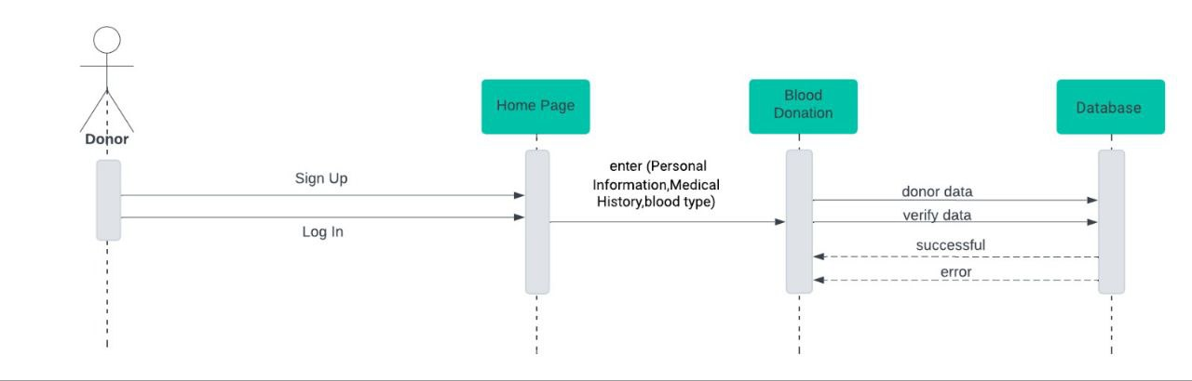blood donation feilds

Figure : Bood donation fields

صورة تحتوي على نص, رسم بياني, لقطة شاشة, خطة

تم إنشاء الوصف تلقائياً

Figure : The food parcels.

صورة تحتوي على نص, رسم بياني, موازِ, خط

تم إنشاء الوصف تلقائياً

Figure : Orphans

Figure : Orphans fields

صورة تحتوي على نص, رسم بياني, لقطة شاشة, خطة

تم إنشاء الوصف تلقائياً

Figure : Mosque

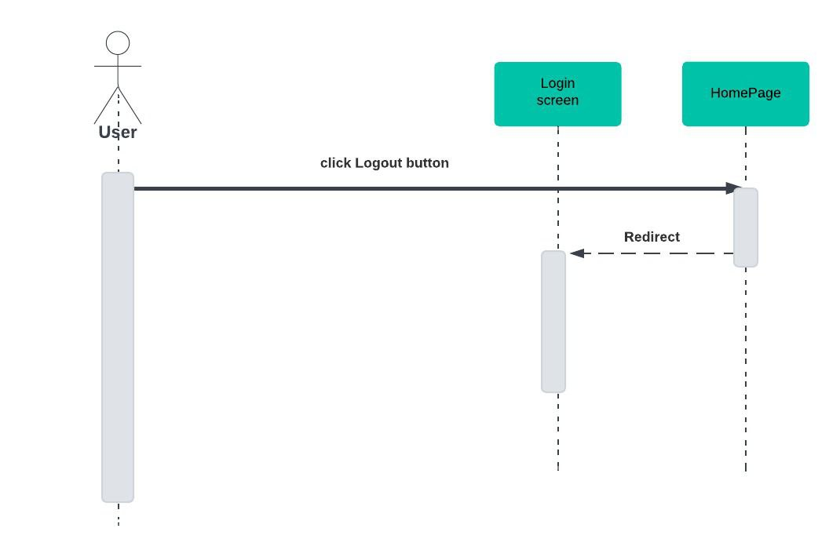

Figure : Logout

Chapter Five

# 5.1 Project Implementation

## 5.1.1 The Programming Language.

We use Html, CSS, JavaScript, PHP

## Segment of the most important part of implementation

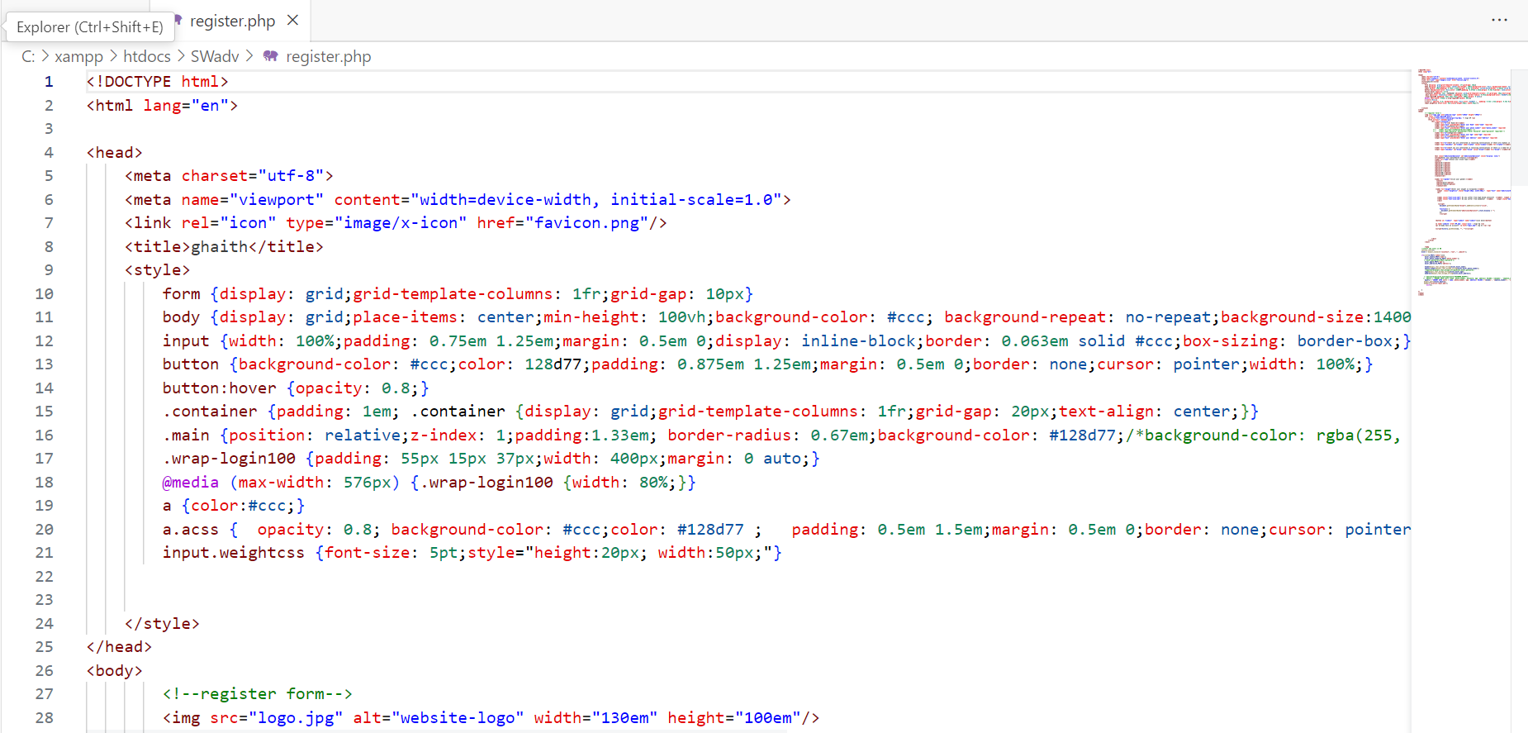

Figure : Registration

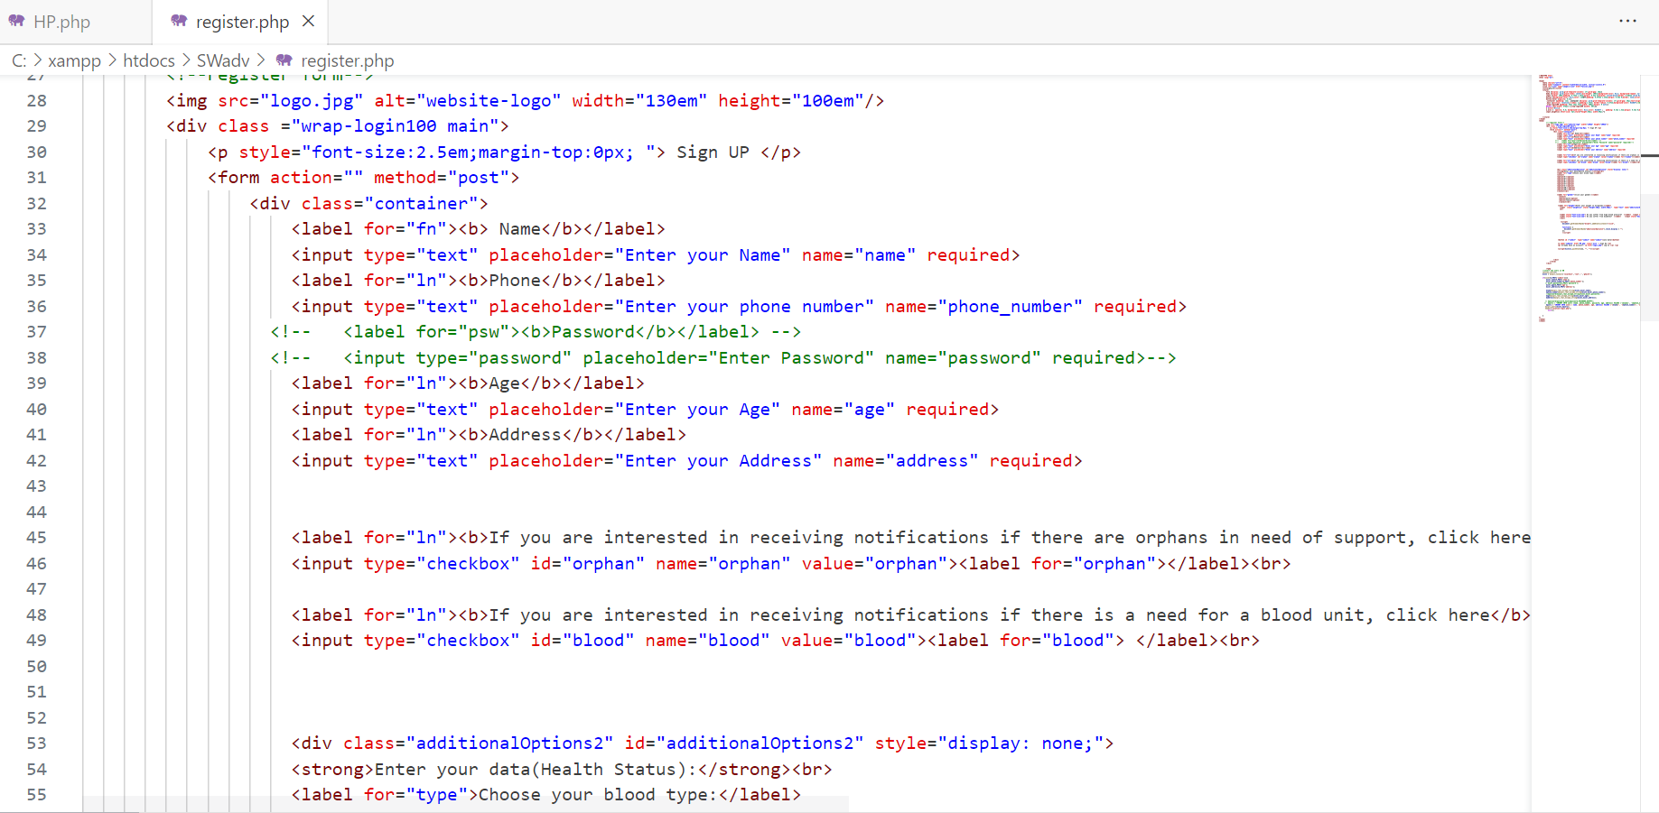

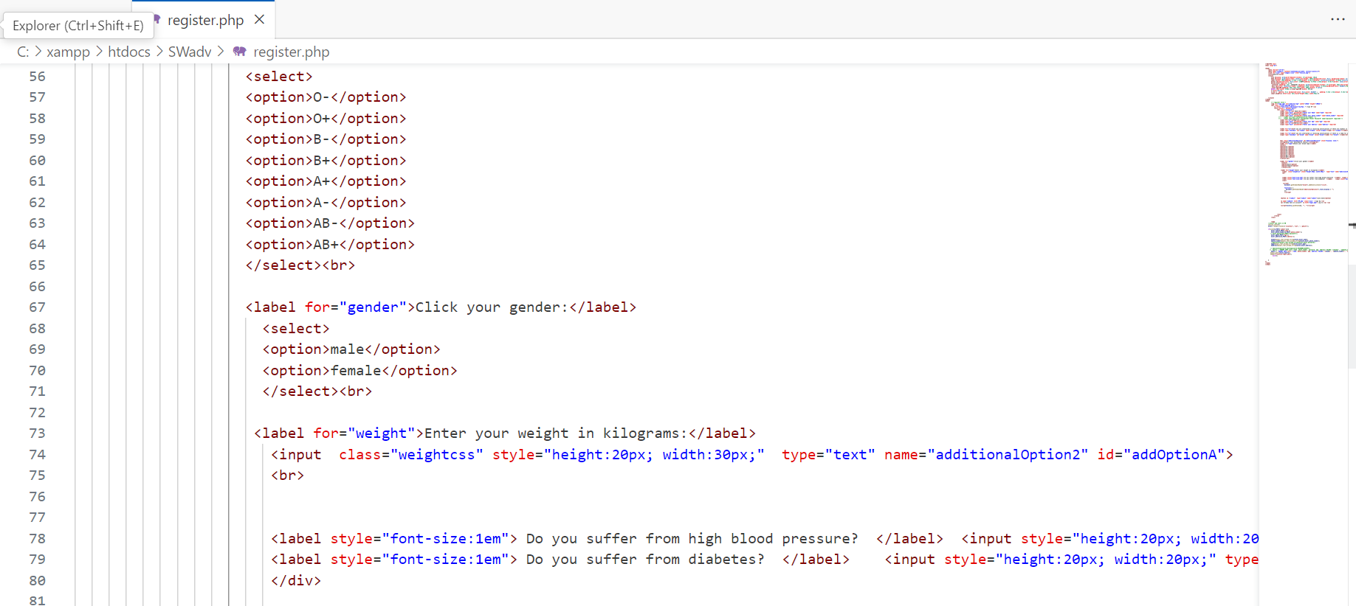

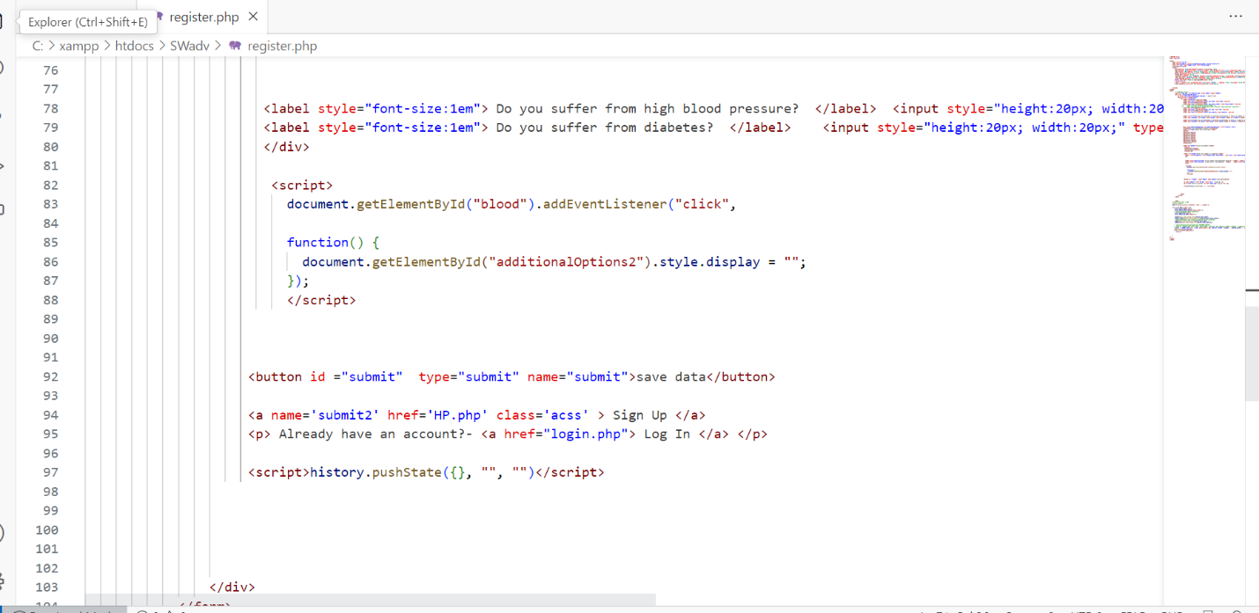

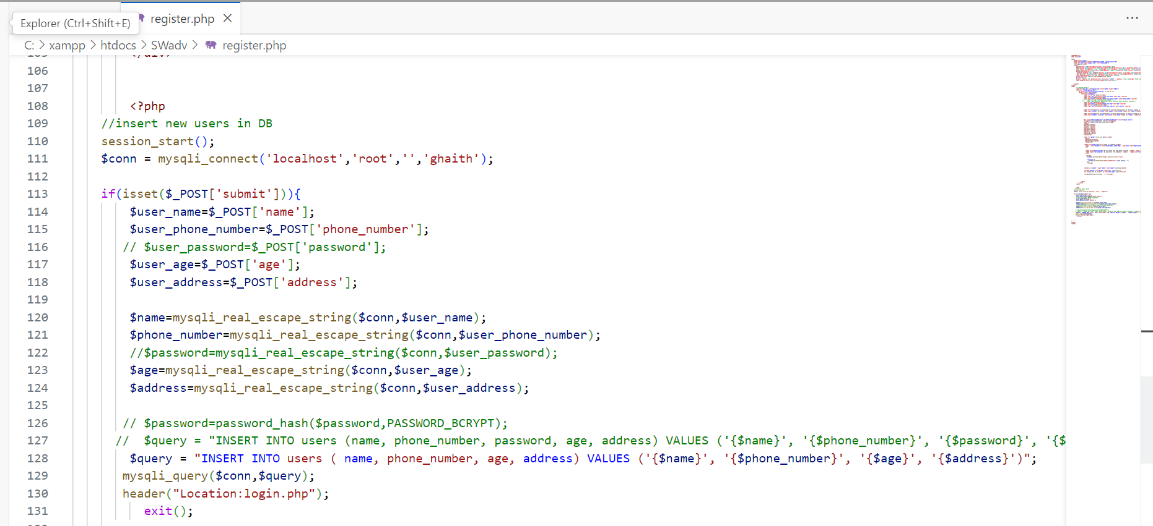

Figure : Home Page

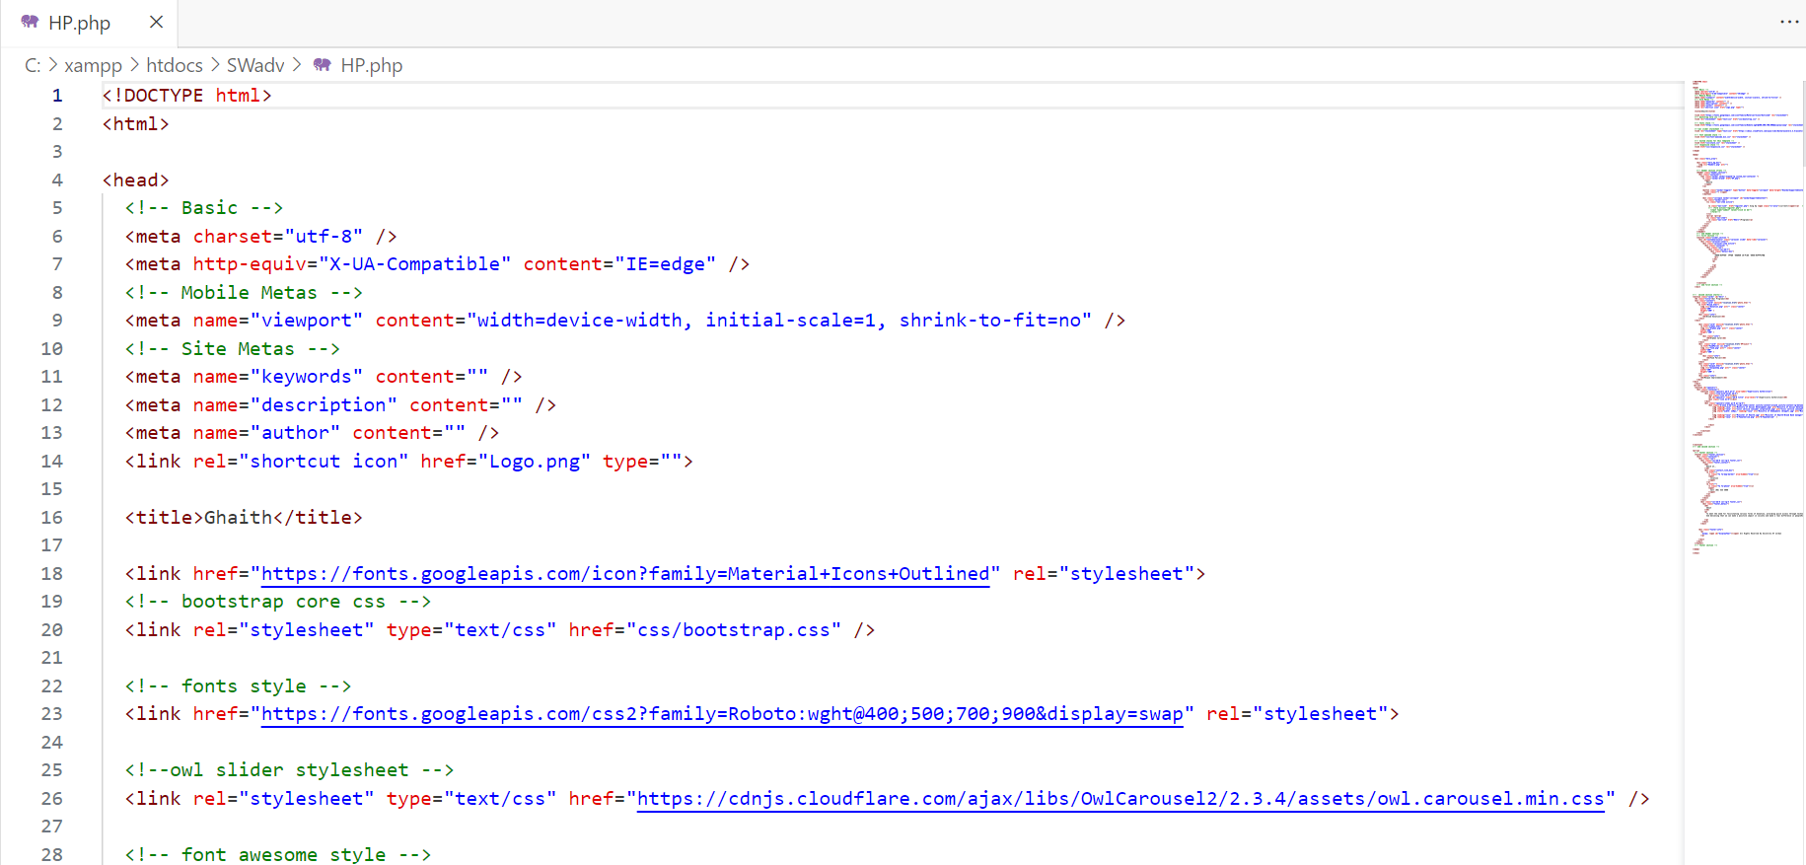

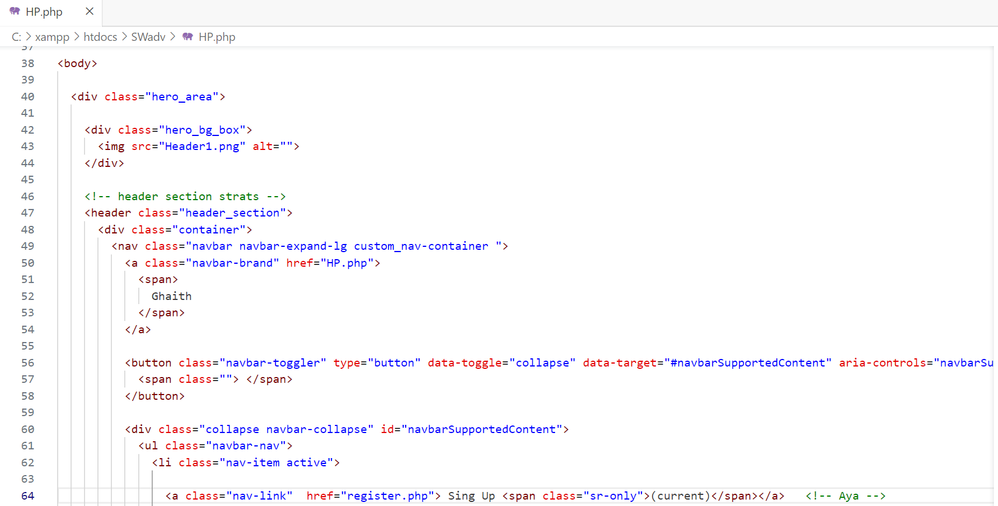

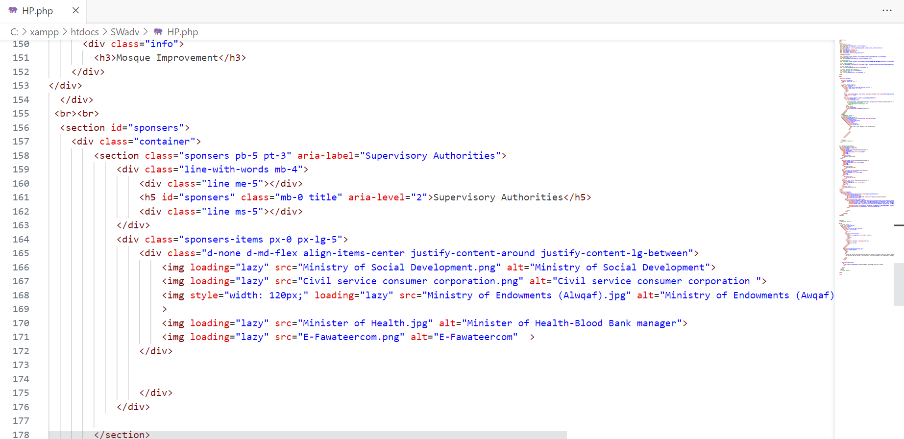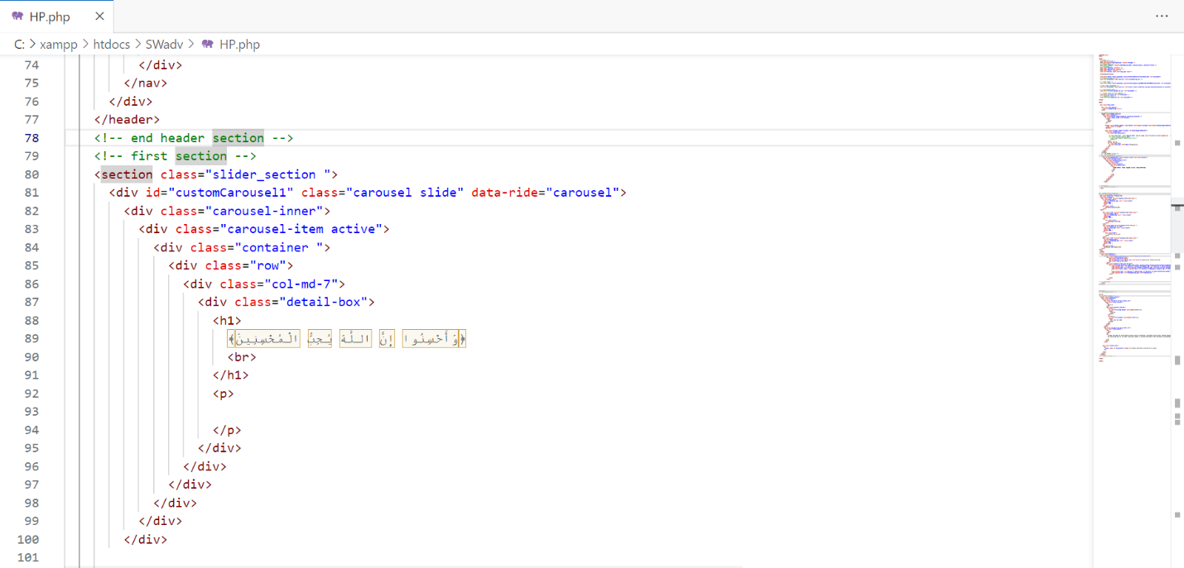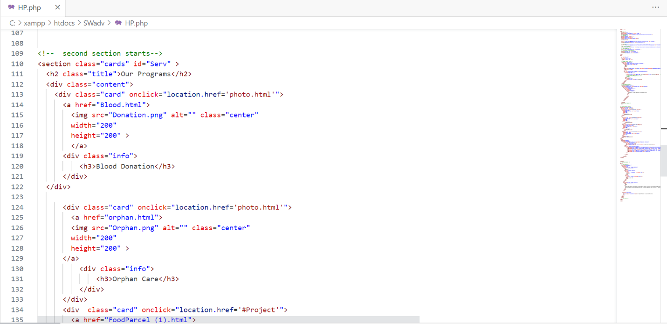

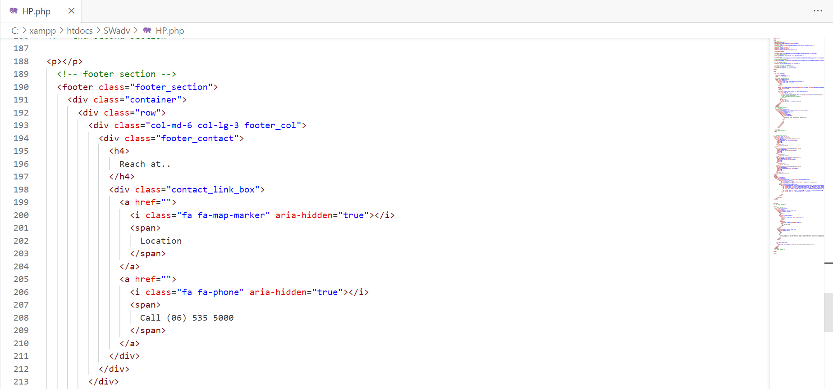

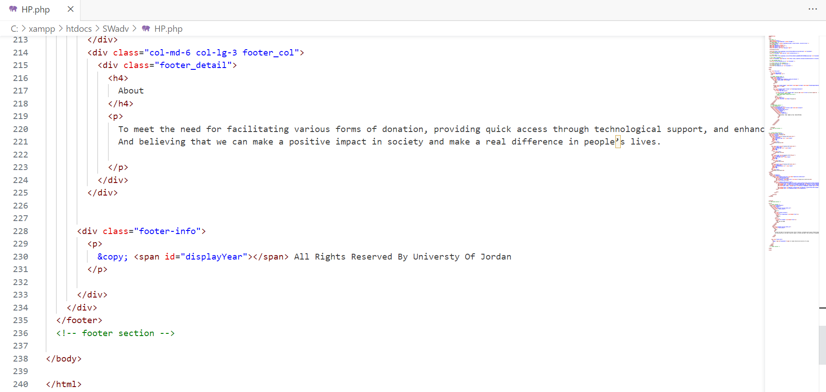

Chapter Six

# 6.1 Project Testing

## 6.1.1Test cases

Table : Test Cases

|  |  |  |  |  |  |
| --- | --- | --- | --- | --- | --- |
| **Test scenario** | **Test cases** | **Test data** | **Expected results** | **Actual results** | **Pass/ Fail** |
| 1- Check user sign up | enter Name, Phone Number, Age, and Address | valid Phone Number | Login must be successful | home page appears | Pass |
| 2- Check user login | enter Phone Number | valid Phone Number | Login must be successful | user home page appears | Pass |
| 3- Check login functionality | Check response on entering invalid Phone Number | invalid Phone Number | “Required” should be displayed | Login not successful | Pass |
| 4- Check sign up functionality | Check response on entering invalid Phone Number | invalid Phone Number | “Required” should be displayed | Sign up not successful | Pass |

|  |  |  |
| --- | --- | --- |
| Numbering scheme | Heuristic | Description |
| H1 | **Visibility of system status.** | The system should always keep user’s informed about what is going on, through appropriate feedback within reasonable time. |
| H2 | **Match between system and the real world.** | The system should show information in the user’s language, with words, phrases and concepts familiar to the user, rather that system-oriented terms.  Follow real-word conventions, making information appear in a natural and logical order. |
| H3 | **User control and freedom** | User’s often choose system functions by mistake and will need a clearly marked “emergency exits” to leave the unwanted state. Support message dialog and help instruction. |
| H4 | **Consistency and standards** | User’s should not have to wonder whether different data, situations, or actions mean the same thing. |
| H5 | **Help users recognize, diagnose and recover from errors.** | Error messages should be expressed in plain language (no code), precisely indicating the problem, and constructively suggesting a solution. |
| H6 | **Error prevention.** | Even better than a good error message is a careful design that prevents a problem from occurring in the first place. |
| H7 | **Recognition rather than recall.** | Make objects, actions, and options visible. The admin should not have to remember information from one part of the dialogue to another. Instructions for use of the system should be visible or easily retrievable whenever appropriate |
| H8 | **Flexibility and efficiency of use.** | Accelerators - unseen by the novice user – may often speed up the interaction for the expert user such that the system can cater to both inexperienced users. Allow user to tailor frequent actions. |
| H9 | **Aesthetic and minimalist design.** | Dialogues should not contain information that is irrelevant or rarely needed. Every extra unit of information in a dialogue competes with a relevant unit of information and diminishes their relative visibility. |
| H10 | **Help and documentation** | Even though it is better if the system can be used without documentation, it may be necessary to provide help and documentation. Any such information should be easy to search, focused on the user’s task, list concrete steps to be carried out, and not to be too large. |

## 6.1.2 Test methodologies

Table : Heuristic evaluation

Table : Summary of Violations by Heuristics

|  |  |  |
| --- | --- | --- |
| Numbering Scheme | Frequency | Ratio (%) |
| H1 | 5 | 10.00 |
| H2 | 5 | 10.00 |
| H3 | 3 | 06.00 |
| H4 | 3 | 06.00 |
| H5 | 10 | 20.00 |
| H6 | 2 | 04.00 |
| H7 | 5 | 10.00 |
| H8 | 6 | 12.00 |
| H9 | 4 | 08.00 |
| H10 | 7 | 14.00 |
| Total | **50** | **100%** |

system was tested by three IT experts and there are the results:

Table : Severity rating and their Description

|  |  |
| --- | --- |
| Severity Rating | Description |
| 0 | I don’t agree that this is a usability problem at all |
| 1 | Cosmetic problem only: need not to be fixed unless extra times are available on project. |
| 2 | Minor usability problems: Fixing this should be given low priority. |
| 3 | Major usability problem: import to fix, so should be given high priority. |
| 4 | Usability Catastrophe: Import to fix this before product can be released. |

Table : Summary of Violations by Severity Rating for Participant (1)

|  |  |  |
| --- | --- | --- |
| Severity Rating | Frequency | Ratio (%) |
| 0 | 6 | 0.60 |
| 1 | 2 | 0.20 |
| 2 | 1 | 0.10 |
| 3 | 1 | 0.10 |
| 4 | 0 | 0.00 |
| Total | 10 | 100% |

Table 14: Summary of Violations by Severity Rating for Participant (2)

|  |  |  |
| --- | --- | --- |
| Severity Rating | Frequency | Ratio (%) |
| 0 | 5 | 0.50 |
| 1 | 1 | 0.10 |
| 2 | 2 | 0.20 |
| 3 | 1 | 0.10 |
| 4 | 1 | 0.10 |
| Total | 10 | 100% |

Table 15: Summary of Violations by Severity Rating for Participant (3)

|  |  |  |
| --- | --- | --- |
| Severity Rating | Frequency | Ratio (%) |
| 0 | 3 | 0.30 |
| 1 | 0 | 0.00 |
| 2 | 3 | 0.30 |
| 3 | 1 | 0.10 |
| 4 | 3 | 0.30 |
| Total | 10 | 100% |

Chapter Seven

# 7.1 User Manual

The login popup screen will appear when pressing the login button under the sign up page

The sign up popup screen will appear when pressing the sign up button

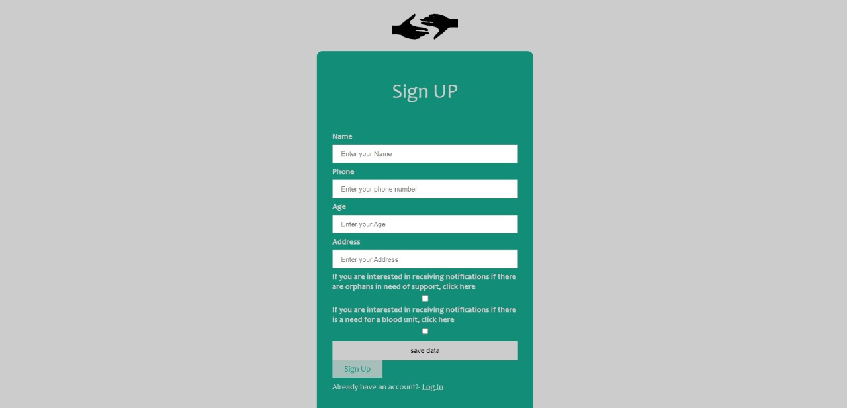

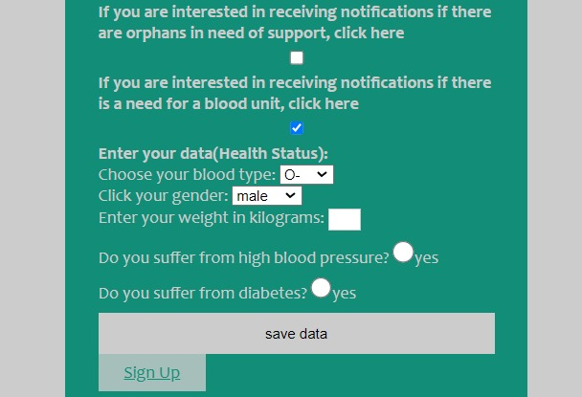

On the sign up page, below there are options to choose the notification you want and to fill in your important information in order to donate

This is Home page that the user will find when opening the website

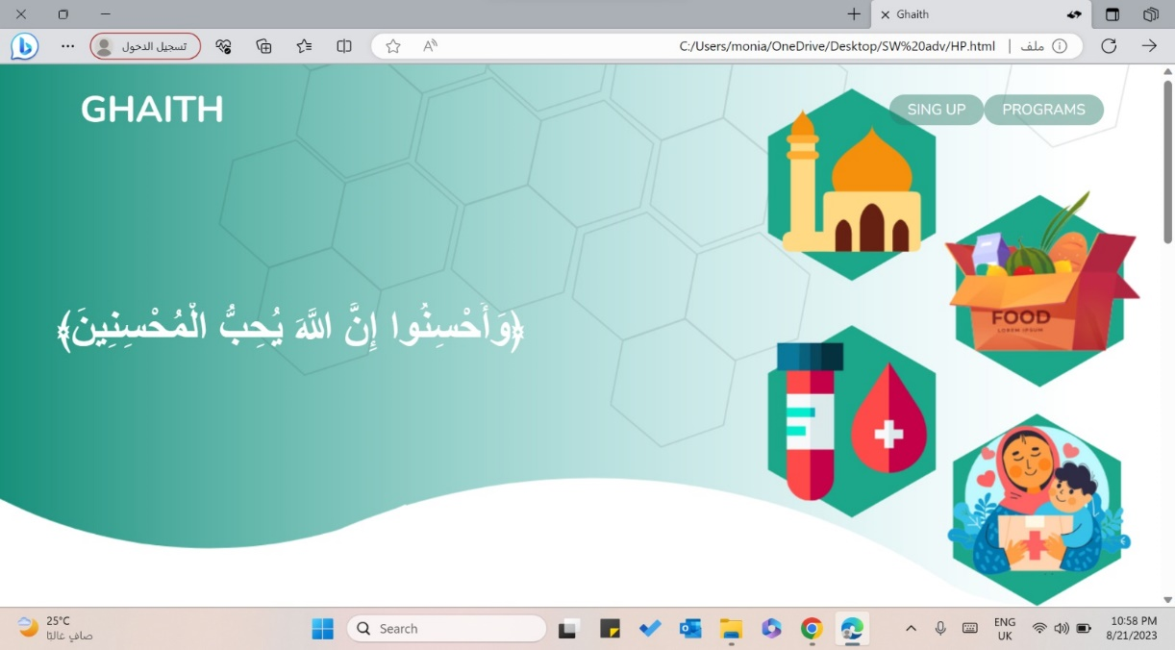

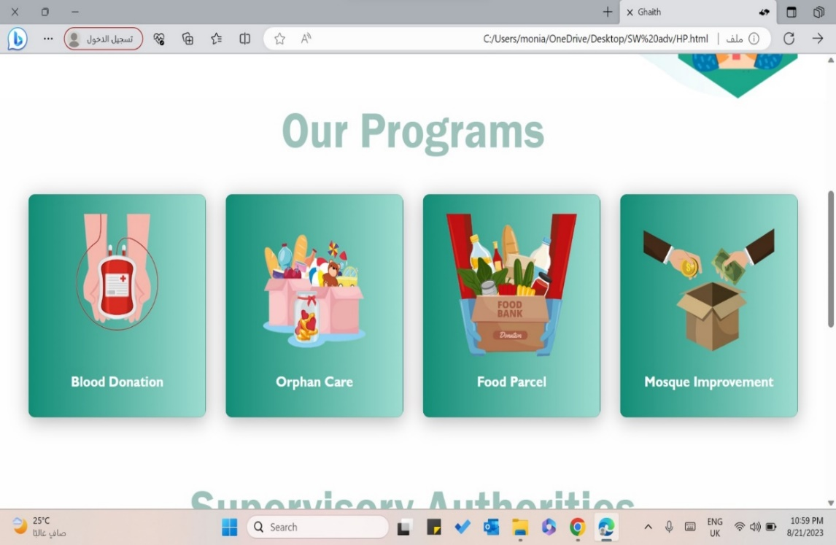

When scrolling down on the same page, you will find various donation programs, which are blood donation, orphan sponsorship, food parcel and mosque improvement.

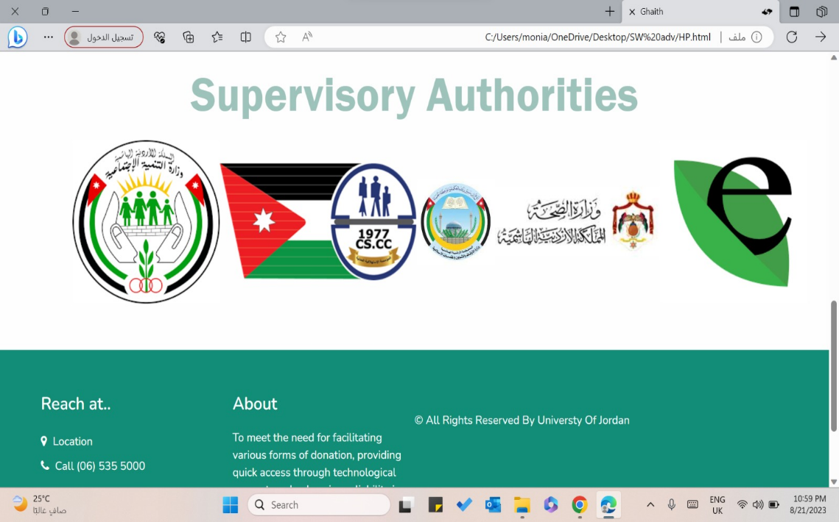

When scrolling down on the same page, you will find the Supervisory authorities

After completing the sign up process successfully, you can choose the type of program that you want to donate, for example donating blood. This page will appear to you after clicking on its icon.

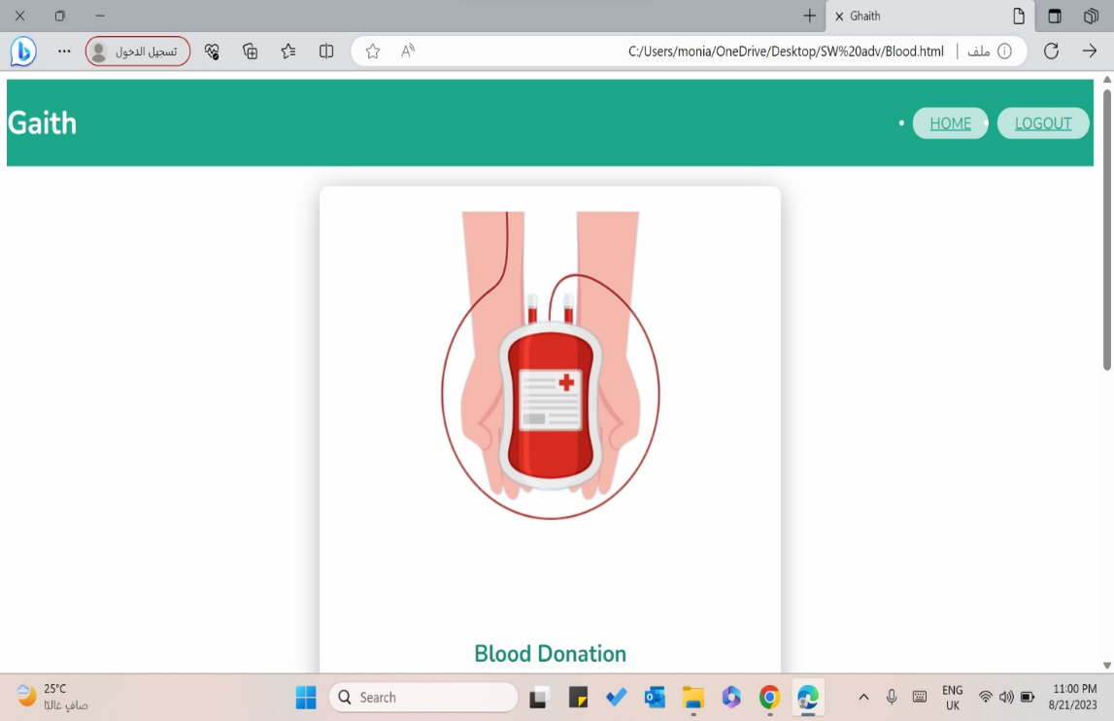

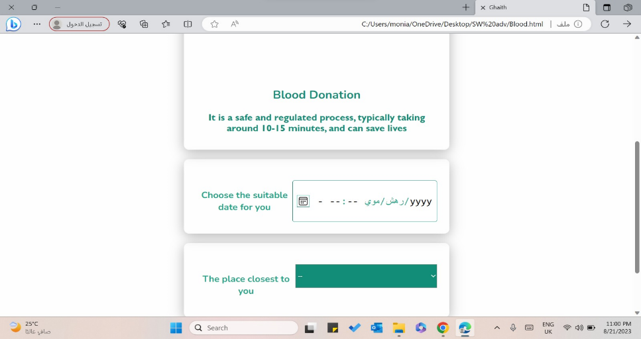

When scrolling down on the same page, you will find an appointment registration page to donate blood

After completing the sign up process successfully, you can choose the type of program that you want to donate, for example, orphan sponsorship. This page will appear to you after clicking on its icon.

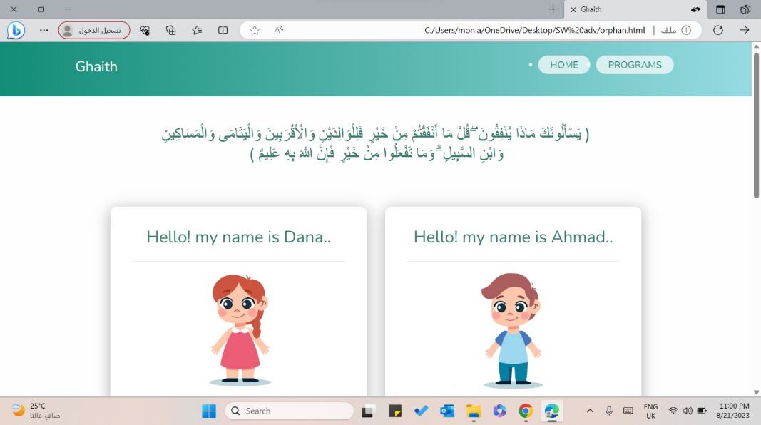

When scrolling down on the same page, the donor can choose the amount depending on the number of months

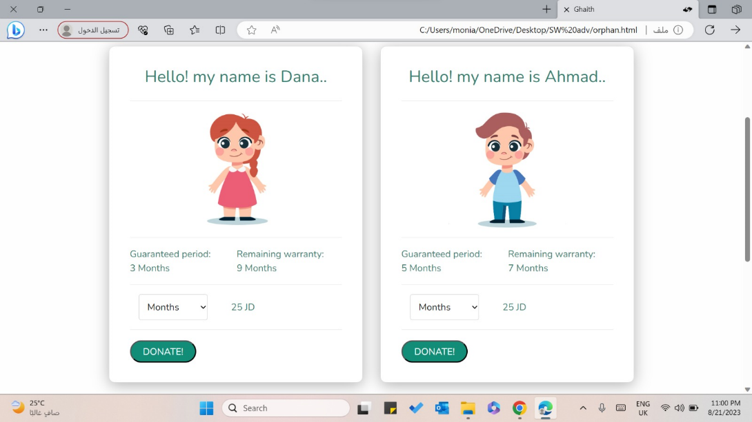

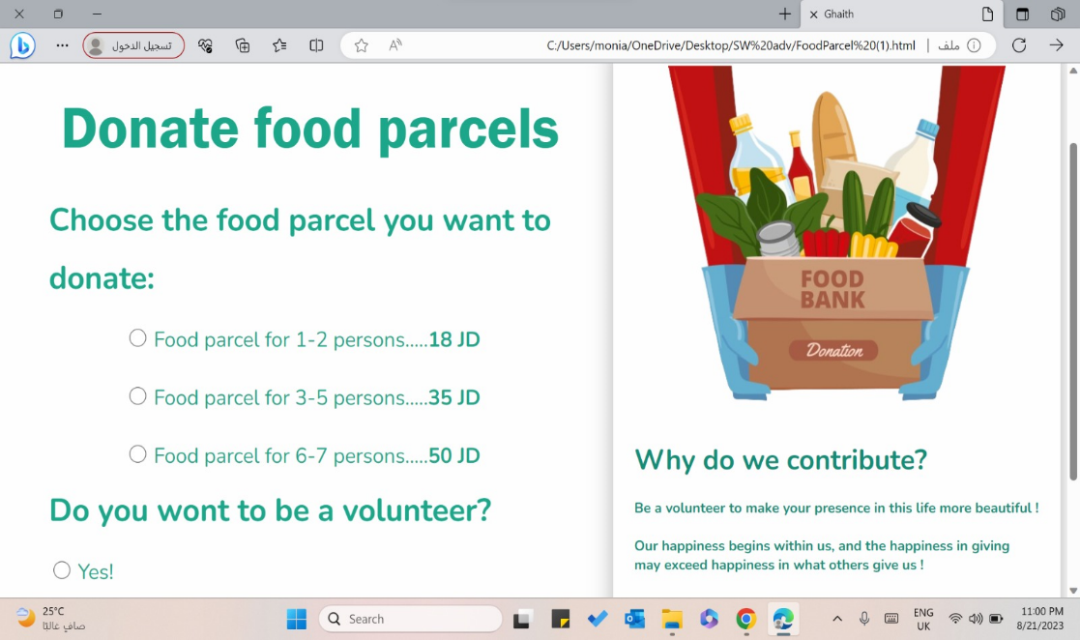

After completing the sign up process successfully, you can choose the type of program that you want to donate, for example, food parcels. This page will appear to you after clicking on its icon, The donor can choose the number of people he wants to donate for them the food parcel

After completing the sign up process successfully, you can choose the type of program that you want to donate, for example, mosque improvement This page will appear to you after clicking on its icon.

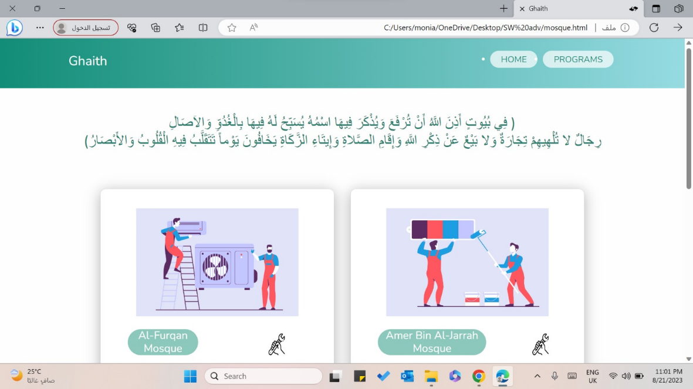

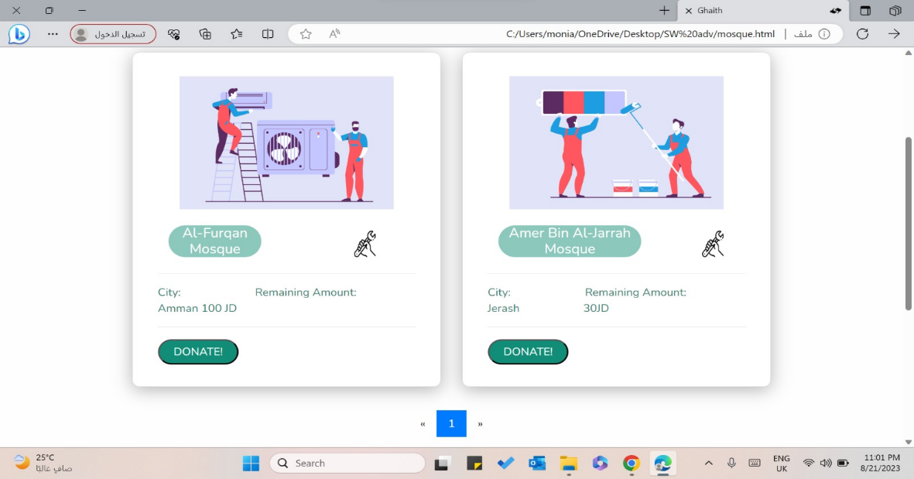

When scrolling down on the same page, the donor can choose the mosque he wants to donate for

# References

* Sommerville, Ian, Software engineering, 10th edition, 2015, Welly.
* Hudaib, Amjad, Lecture Notes of Advanced Software Engineering Course, Summer Semester, 2023.
* Chat GPT
* W3school
* Liquid
* CodePen

Appendix

Survey:

Questionnaire: we put out a google form to a group of people

Interview:

Interview: we gathered information and requirements from project lead to understand their needs and expectations for a software project. It involves asking questions and discussing various aspects of the project to ensure a clear understanding of the scope, requirements, and desired outcomes. The information collected during interviews serves as the foundation for designing and developing an effective.

Source Code:

https://github.com/MONIADAHNOON/Ghaith-website